Notes on fitting DEBkiss model for unstressed *M. menidia* with survival variable

Data and Code

* Roger added the code for a survival variable to the pond snail with egg DEBkiss code.
  + There is an initial value for survival added under ‘Initial values for the state variables’.
  + There are two parameters added to the list, mu_emb and mu_lar, for the mortality rates. These are proportion per day I assume? And once they become juveniles does mortality end?
    - No, it looks like larval survival is applied any time after the egg buffer is depleted.
  + Turn legends off.
* First ran without any data for survival. Next needed to organize the data and see how realistic the survival rates are for different ages at 24C, constant lab conditions. Then redid with survival data entered in.
  + The NLL and AIC changed (went up) but the parameter estimates didn’t change. Probably because it is not fitting the model to the survival data, but still counting the differences between predicted and observed survival in the NLL/AIC calculations.
* Lwp – do I need to change it to something like 60-90 days? When does gonad growth start?
* What is going on with hatching, why don’t the change in the length function and egg buffer match up? There are two inflection points in the survival curve.
  + For survival data is it okay to have multiple survival rates for the same age or should I use the average?
* December 2022 – added survival data from Murray et al (2017), added 14 to each age because they hatched at 14dpf (experiment was done at 17C).
  + Other survival data from Cross et al (2019) and Murray and Baumann (2018) was done at temperatures of 24C. Can I still use them both?
  + I would think the later juvenile survival rates would be similar still.
* December 2022 – added data for egg buffer as egg buffer is max size at 0 dpf and egg buffer is zero at hatching which is 6dpf.
  + Where did initial weight of egg buffer come from?
  + In Klahre (1997) they range from 0.12 to 0.18 mg, maybe use 0.15. I couldn’t find any other data.
* After adding these two I redid the manual fitting to narrow down the initial parameters.
  + Made fB=1, yVA=0.15 from 0.2 to get hatching to match up.
  + Increased mu_emb to 0.07 to get survival at hatching closer to 0.67 (the unweighted average of the data I have input).
* Lwp is 120 but that is actually high. It is the length they start reproducing, around 300 dpf. So I think it needs to stay around there.
* The new set of initial parameters that gives close fits to the length at age (with a maximum around 12.5cm), initiation and rate of reproduction, hatch timing, and survival rates is:
  + delM = 0.1066
  + dV = 0.1
  + sJAm = 0.27
  + sJM = 0.015
  + WB0 = 0.15
  + Lwp = 115
  + yAV = 0.8
  + yBA = 0.95
  + yVA = 0.15
  + kap = 0.75
  + f = 1
  + fB = 0.9
  + Lwf = 0
  + mu_emb = 0.07
  + mu_lar = 0.01
* For minus log likelihood it said ‘Inf’. Why??
  + This was apparently caused by setting fB=1 after changing it from 0.5.
  + As you increase fB the NLL decreases but if you go above 0.92 it becomes Inf.
  + The shape of the egg buffer curve is affected.
  + As the fB increases from 0.5 to 0.92 the hatching (egg buffer=0) comes closer to the correct day reflected in the data, which is why NLL goes down. Maybe if it goes below this then that’s why NLL couldn’t be calculated?
  + If I change other things that affect the depletion of egg buffer a similar pattern might happen.
* Also updated to latest version of BYOM

Progress

* First run code with fitting turned off.
  + Survival hits zero around 200 days which is not realistic. Decrease mu_lar.
  + Setting mu_lar=0.01 (originally was 0.02) increases survival to >400 days, that is fine for now. Survival to hatch is on the low end of the data, at ~64%.
  + Actually it is hard to see but there are two inflection points, one at (6.06, 0.738) and the other at (12.12, 0.64). Hatching is at 12.12 days according to egg buffer, but 6.06 days according to total length.

60 day plot:

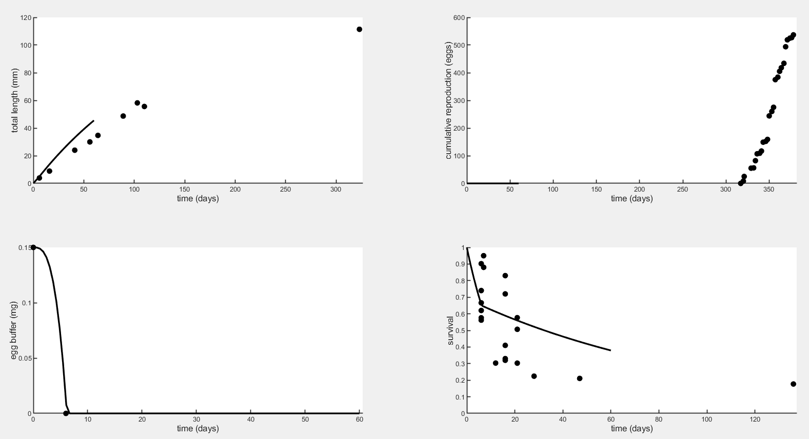

600 day plot:

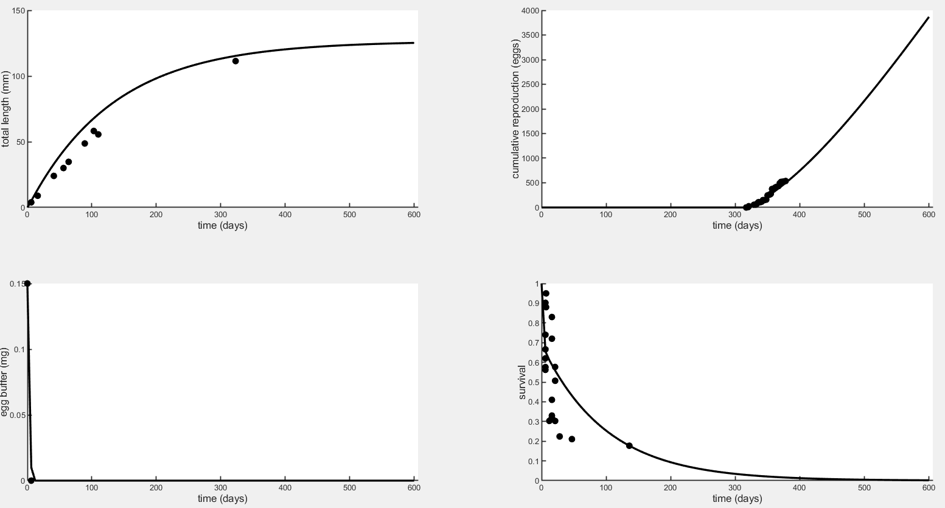

Fit with one parameter free at a time, record estimate, AIC, and NLL below.

|  |  |  |  |  |  |
| --- | --- | --- | --- | --- | --- |
|  | **Initial parameters** | **Parameters estimated from ODE** | **AIC** | **Negative Log-Likelihood** | **Notes** |
| delM | 0.1066 (data) | - |  |  |  |
| dV | 0.1 | - |  |  |  |
| sJAm | 0.27 | 0.2705 | 530.48 | 264.24 | Repro improved |
| sJM | 0.015 | 0.01497 | 530.38 | 264.19 | Repro improved |
| WB0 | 0.15 | 0.1345 | 523.46 | 260.73 | Repro higher |
| Lwp | 115 (data) | 114.8 | 530.93 | 264.46 | Repro improved |
| yAV | 0.8 | 1.6e-15 | 538.16 | 268.08 | Egg depletion incr |
| yBA | 0.95 | 1.000 | 529.21 | 263.60 | Repro hi like WB0 |
| yVA | 0.15 | 0.1513 | 531.76 | 264.88 | Repro improved, egg depletion incr |
| kappa | 0.75 | 0.7514 | 531.09 | 264.54 | Repro improved |
| f | 1 (ad libitum) | 1.002 | 530.68 | 264.34 | Repro improved |
| fB | 0.9 | 0.9284 | 429.39 | 213.69 | Egg buf, surv chg |
| Lwf | 0 | 0.000 | 539.17 | 268.59 | Nothing changed |
| mu_emb | 0.07 | 0.07712 | 538.84 | 268.42 | Hatch surv lower |
| mu_lar | 0.01 | 0.02733 | 534.57 | 266.29 | Larval surv lower |

With no fitting or parameter estimation, NLL=268.586 (AIC not stated but I guess it is about 537).

**Should I replace the initial parameters with these estimates?**

Ranked by AIC, lowest (best fit) to highest (worst):

|  |  |  |
| --- | --- | --- |
| **Parameter** | **AIC** | **Notes** |
| fB | 429.39 | Egg buffer depleted faster, survival changed slightly |
| WB0 | 523.46 | Reproduction higher overall |
| yBA | 529.21 | Reproduction higher overall, similar to WB0 effect |
| sJM | 530.38 | Reproduction fit improved |
| sJAm | 530.48 | Reproduction fit improved |
| f | 530.68 | Reproduction fit improved but estimate is unrealistic |
| Lwp | 530.93 | Reproduction fit improved |
| kappa | 531.09 | Reproduction fit improved |
| yVA | 531.76 | Reproduction fit improved, egg buffer depleted faster until last bit |
| mu_lar | 534.57 | Larval survival is lower, poor fit to the data point at 136 days |
| yAV | 538.16 | Egg buffer depleted faster, estimate is basically zero |
| mu_emb | 538.84 | Hatch survival is lower, about 0.6 |
| Lwf | 539.17 | Nothing changed |

* Find out what fB means
  + Scaled food level, embryo
  + If WB>0 then f=fB, and f is multiplied by sJAm to get JA (assimilation flux) so this is a way of having a different assimilation flux for an embryo.
  + But what is a good value for it? Should I manually change it and see how it affects the fit?
    - Decreasing it to 0.1 makes lower NLL but it delays hatching by way too much.
    - How is this different than changing sJAm?
    - The low number it landed on is why hatching was delayed, and maybe the reason for the low number is because there is no hatching (or egg buffer) data being used in the estimation.
* Find out what Lwf means and if I should leave it as 0
  + Half saturation length for initial food limitation
  + Used in translating length to weight WVf, which is then used for adjusting f but I don’t understand why.
  + Maybe it doesn’t apply here because f=1 so food is always at full saturation? Assuming the ‘half-saturation’ is referring to food?
* Find out what it means to fit for f and if it makes sense.
  + f is multiplied by sJAm to get JA so it makes sense that they had similar effects on the fit.
  + It doesn’t make sense to fit for f because all experiments were ad libitum so it is known that f=1. It is also not necessary because we can get a similar effect by fitting for sJAm.
* The top parameters are fB, yVA, kappa, Lwp, sJAm, f, and sJM. The top candidates are in this list. Above all is fB and yVA, then the others have pretty similar AICs.
* Next step is doing combinations of two parameters, but need to shorten list so it doesn’t take 1000 years.
  + Priority: fB, yVA, kappa, sJAm, and sJM
    - Aka most influential for fit because they reduced AIC the most from the one with no fitting.
  + The formula for all unique pairs of a set of n members is n(n-1)/2, so for 5 parameters that is 10 combinations. Not bad.
  + fB & yVA
  + fB & kappa
  + fB & sJAm
  + fB & sJM
  + yVA & kappa
  + yVA & sJAm
  + yVA & sJM
  + kappa & sJAm
  + kappa & sJM
  + sJAm & sJM

|  |  |  |  |  |  |
| --- | --- | --- | --- | --- | --- |
|  | **Initial parameters** | **Parameters estimated from ODE** | **AIC** | **Negative Log-Likelihood** | **Notes** |
| fB | 0.5 | 0.07789 | 492.71 | 244.35 | Time to hatching is unrealistic, 54d |
| yVA | 0.2 | 0.2223 |
|  | | | | | |
| fB | 0.5 | 0.08553 | 479.03 | 237.52 | Time to hatching is unrealistic, 48d |
| kappa | 0.75 | 0.7603 |
|  | | | | | |
| fB | 0.5 | 0.08539 | 476.27 | 236.14 | Time to hatching is unrealistic, 54d |
| sJAm | 0.27 | 0.2734 |
|  | | | | | |
| fB | 0.5 | 0.08731 | 475.28 | 235.64 | Time to hatching is unrealistic, 48d |
| sJM | 0.015 | 0.01478 |
|  | | | | | |
| yVA | 0.2 | 0.1491 | 491.61 | 243.80 | Looks good |
| kappa | 0.75 | 0.7818 |
|  | | | | | |
| yVA | 0.2 | 0.1615 | 494.59 | 245.30 | Looks good |
| sJAm | 0.27 | 0.2765 |
|  | | | | | |
| yVA | 0.2 | 0.1639 | 494.05 | 245.03 | Looks good |
| sJM | 0.015 | 0.01461 |
|  |  |  |  |  |  |
| kappa | 0.75 | 0.6276 | 503.10 | 249.55 | Looks good |
| sJAm | 0.27 | 0.3186 |
|  | | | | | |
| kappa | 0.75 | 0.6736 | 498.30 | 247.15 | Looks good |
| sJM | 0.015 | 0.01341 |
|  | | | | | |
| sJAm | 0.27 | 0.1959 | 485.98 | 240.99 | Looks good |
| sJM | 0.015 | 0.01019 |

* Since fitting for fB always results in an unrealistic fit (time to hatching takes way too long, maybe could be improved if include data), here are the best fits not including fB:
  + sJAm & sJM
  + yVA & kappa
  + yVA & sJM
  + yVA & sJAm
* All of these reduced AIC a lot (~30) from when only one parameter was fitted, despite the penalty AIC uses for additional parameters.
* Next step is to fit with the following combinations of 3:
  + sJAm, sJM, yVA
  + sJAm, yVA, kappa
  + sJM, yVA, kappa
  + sJAm, sJM, kappa

|  |  |  |  |  |  |
| --- | --- | --- | --- | --- | --- |
|  | **Initial parameters** | **Parameters estimated from ODE** | **AIC** | **Negative Log-Likelihood** | **Notes** |
| sJAm | 0.27 | 0.08945 | 458.00 | 226.00 | These are very far off from initial; length increasing too much maybe. |
| sJM | 0.015 | 0.003931 |
| yVA | 0.2 | 0.3332 |
|  | | | | | |
| sJAm | 0.27 | 0.2834 | 457.62 | 225.81 | Length increases too much maybe, doesn’t plateau. |
| yVA | 0.2 | 0.08216 |
| kappa | 0.75 | 0.9260 |
|  | | | | | |
| sJM | 0.015 | 0.01468 | 463.33 | 228.67 | Length keeps increasing, doesn’t plateau. |
| yVA | 0.2 | 0.09255 |
| kappa | 0.75 | 0.9069 |
|  | | | | | |
| sJAm | 0.27 | 0.1321 | 457.44 | 225.72 | Pretty far off from initial parameters; length doesn’t plateau. |
| sJM | 0.015 | 0.006401 |
| kappa | 0.75 | 0.8349 |

* Does length need to plateau after ~400 to 500 days? Since they die before their second year can we allow growth to keep going up beyond their life span because that part doesn’t matter and we don’t really know whether it would plateau or be indeterminate? The part during their lifespan isn’t unrealistic.
* Best combination (lowest AIC) is sJAm, sJM, and kappa.